User Manual

FMS^{NG} Application

Shell Energy Marketing and Trading India Private Limited
Project Sponsoring Business

Risk MGMT

14 MARCH 2024
Date

Table of Contents
1. Risk MGMT Module Overview 3
1.1. User Interface / Screen Designs 3
2. Menu Network / Screen Navigation 5
2.1. Sub Module – Price 5
2.2. Sub Module – Calendar 8
2.3 Sub Module – Market Risk 9
2.4 Sub Module – Credit Risk 14
3 Report Design and Layout 31
4 Auditing 32

Risk MGMT Module Overview
FMS^{NG} Application is an efficient ETRM System for Domestic Gas Trading, customized to meet business requirement of Shell Energy Marketing and Trading India Private Limited (SEMTIPL).
FMS^{NG} Risk MGMT Module will create and manage all critical risk management elements of the trading system as listed below:
- Forward and Settlement Pricing
- Forward and Spot Calendar management
- Market risk and Credit risk Oprations
- Management and Audit Reports
The Risk Mgmt Module is more relevant for Market operating Team/Manager.

User Interface / Screen Designs

FMS^{NG} offers Responsive UI to enable usability via any smart phone, tab and laptop of any screen size. The Menus of Admin module are as below:

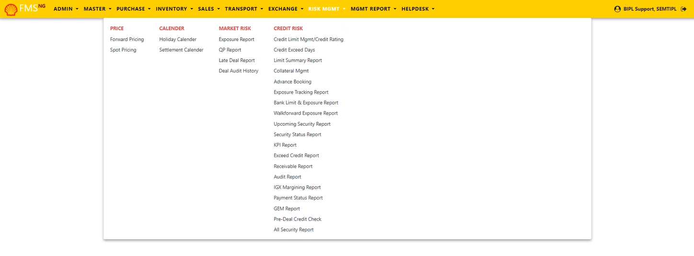

The responsive mode view over iPhone simulation:
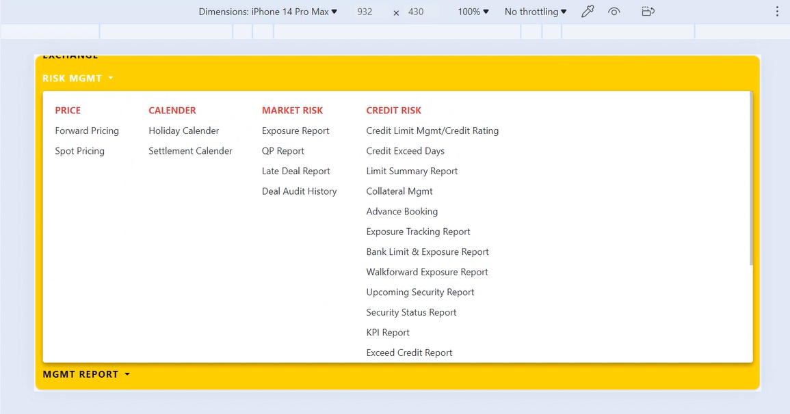

Menu Network / Screen Navigation
Menus in any Module are kept under different Groups for better categorization. The Groups under Risk MGMT Module are Price, Calendar, Market Risk and Credit Risk.

Sub Module – Price

‘Price’ Group provides forms to manage various forward and spot (settlement) price related operations within the application.

Price Forward Pricing

This form incorporates 'Forward Prices' and 'Price Curves' functionalities within the FMS^{NG} application.

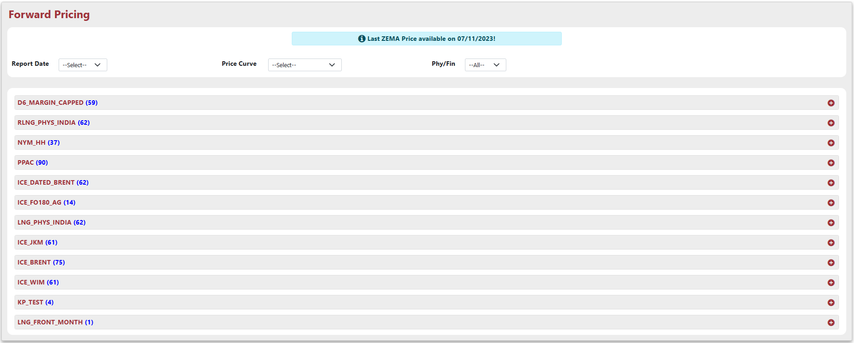

- Filter by report date, price curve, and physical/financial selection for specific data extraction.
- Clicking the "+" (expand) button reveals the detailed table associated with the specific price curve you've clicked on.
- The message "Last ZEMA Price available on ‘Date’!" indicates the system's most recent ZEMA price data is from that date.

Price Spot Pricing

This form incorporates 'Spot (settlement) Prices' and 'Price Curves' functionalities within the FMS^{NG} application.

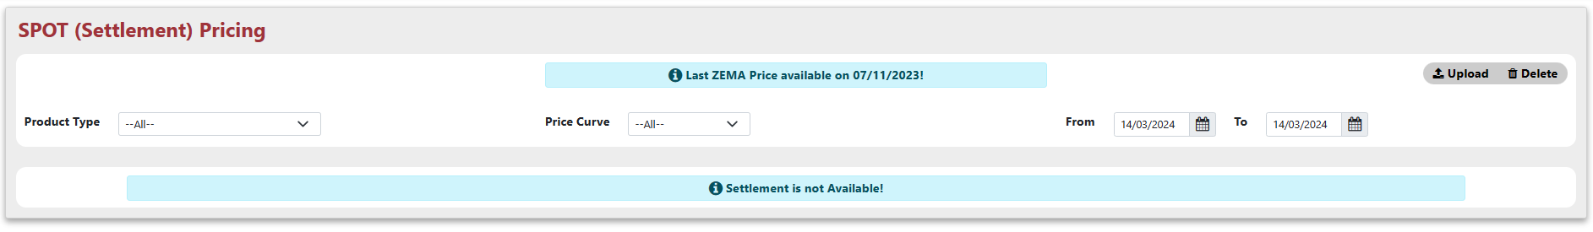

- Selecting product type, price curve, and desired date range (from-to) allows you to filter and view specific data.
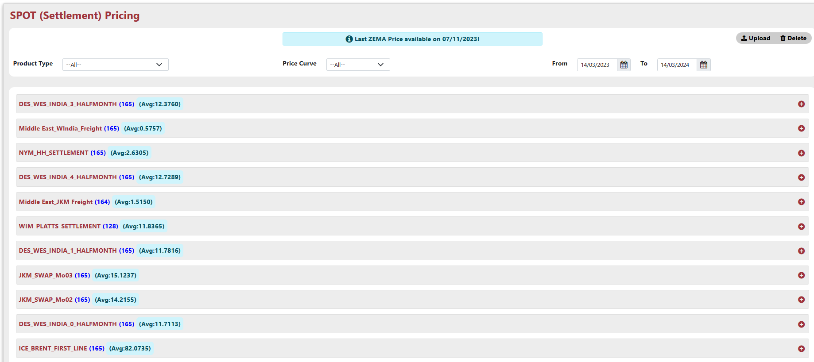
- Clicking the "+" (expand) button reveals the detailed table associated with the specific price curve you've clicked on.
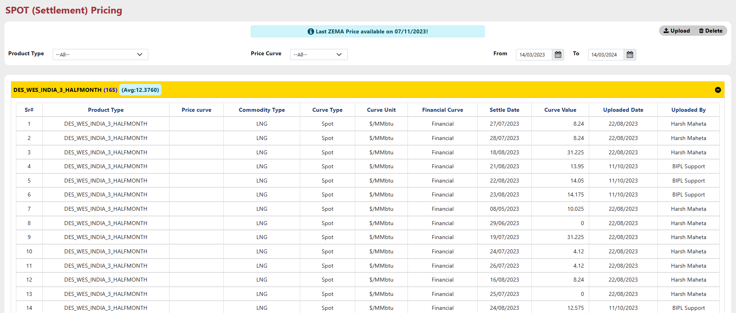

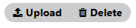
- Clicking "Upload" lets you import pricing data from XML files directly into the system
  - Clicking "Upload" triggers a pop-up window allowing you to select and upload the XML file containing pricing data.
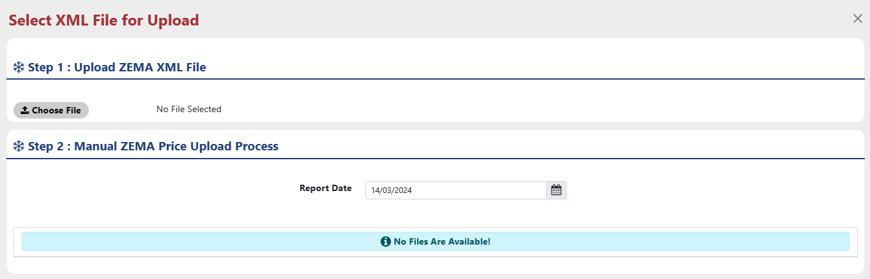
  - Clicking "Choose File" lets you browse and select the specific XML file containing the pricing data you want to upload.
  - "Clicking "OK" confirms uploading the selected XML file containing pricing data."

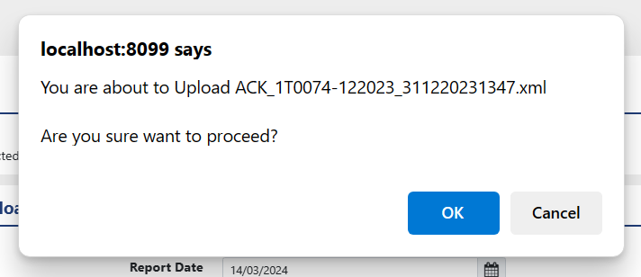

  - Following a successful upload message, return to the upload menu and choose the date corresponding to the uploaded file.
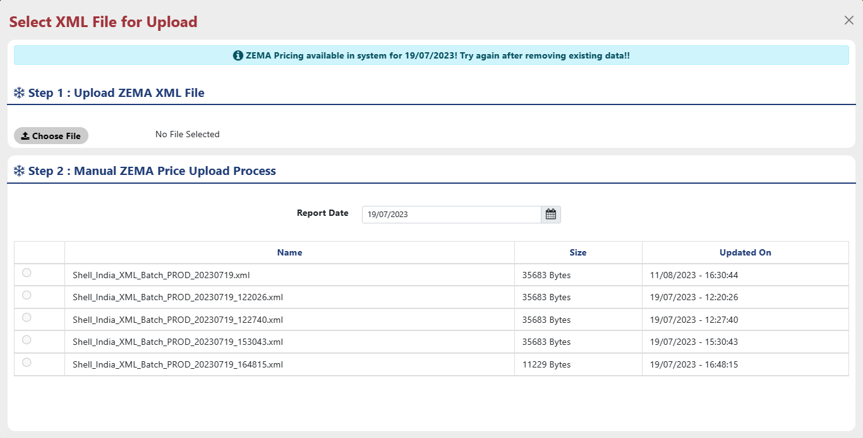
  - Clicking the radio button beside the desired file name in the upload window selects it for uploading pricing data into the system.
  - Uploading pricing data for the same report date is restricted; delete existing data before uploading again using the "Delete" button.

- Clicking "Delete" removes the pricing data associated with the most recent date from the system.
  - Clicking "Delete" prompts a confirmation window, allowing you to remove the most recently uploaded pricing data.
  - Clicking "Delete" removes pricing data for the selected report date, while also displaying the total count of forward and spot prices.
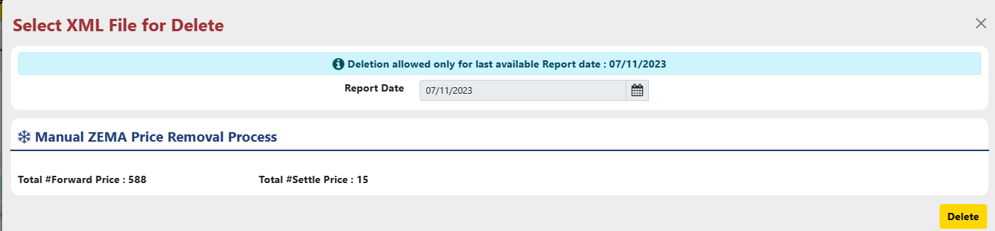

Sub Module – Calendar

The system's calendar acts as a core component, facilitating management of functionalities related to pricing and market schedules within FMS^{NG}.

Calendar Holiday Calendar

The 'Price Curve Holiday Calendar' combines displaying holidays linked to a specific 'price curve' with the functionality to import holidays from an Excel file.
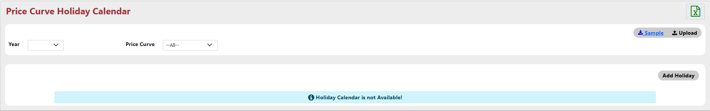

Clicking the "+" (expand) button reveals the detailed table associated with the specific price curve you've clicked on.
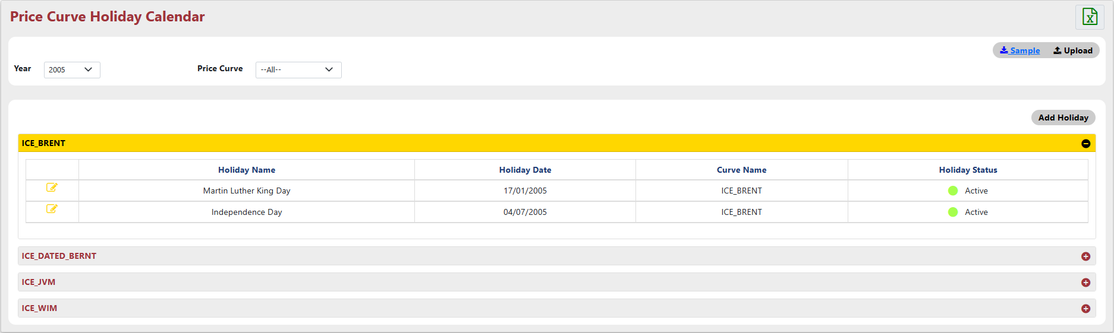

Manage holidays for a price curve: click "Add Holiday" for new entries or the "Pen" icon for existing ones, then provide the necessary details:
- Holiday Name: Name of the specific holiday.
- Holiday Date: Provide the holiday date.
- Price Curve: Select the price curve.
- Status: Indicates whether the tax is currently active or inactive.

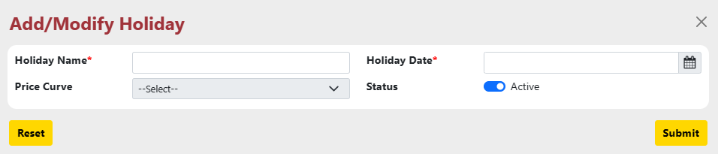

Clicking the "Submit" button saves your edits. However, before finalizing, a confirmation message will likely appear to verify modified tax information.

- The Price Curve Holiday Calendar facilitates uploading holidays into the system; click "Upload" and select the Excel file containing the holiday data.
- Clicking "Sample" downloads a template file (holiday format) to guide you when importing holidays into the system

Calendar Settlement Calendar

The 'Price Curve Settlement Calendar' combines displaying all settlements linked to a specific 'price curve' with the functionality to import settlement dates from an Excel file.

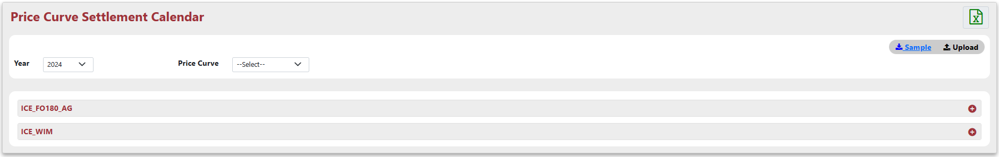

Clicking the "+" (expand) button reveals the detailed table associated with the specific price curve you've clicked on.
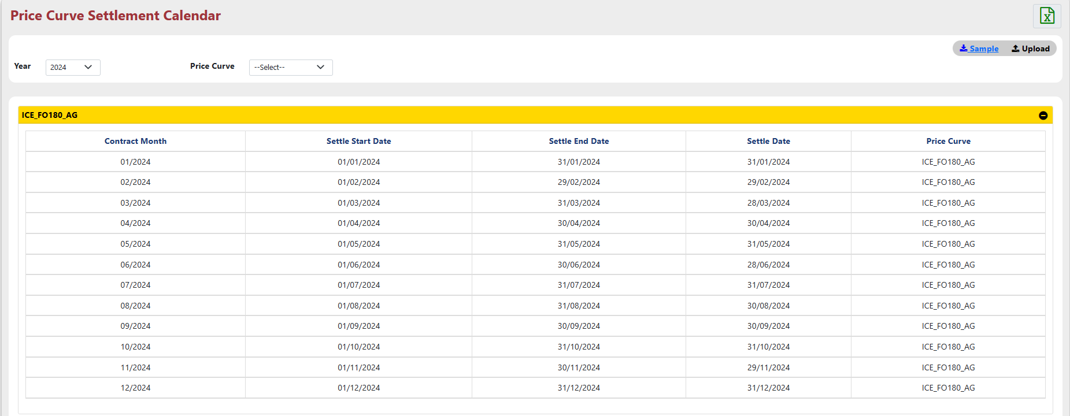

- The Price Curve Settlement Calendar facilitates uploading settlement dates into the system; click "Upload" and select the Excel file containing the settlement data.
- Clicking "Sample" downloads a template file (settlement data format) to guide you when importing settlement dates into the system.

Sub Module – Market Risk

"Market Risk" sub module is used to handle diverse system configurations through the following menus:
- Exposure Report: Get a snapshot of your exposure across deals with details like account, counterparty, contract info, pricing, and curves.
- QP Report: Analyze a specific deal's exposure, forward price, and associated curve (financial/physical) using its deal number.
- Late Deal Report: Late Deal Report identifies overdue deals based on pre-defined criteria.
- Deal Audit History: Tracks all changes made to buy/sell deals for audit purposes.

Market Risk Exposure Report

The "Exposure Report" provides a comprehensive overview of your market risk by showcasing exposure details like account, counterparty, contract information, pricing, and relevant curves.

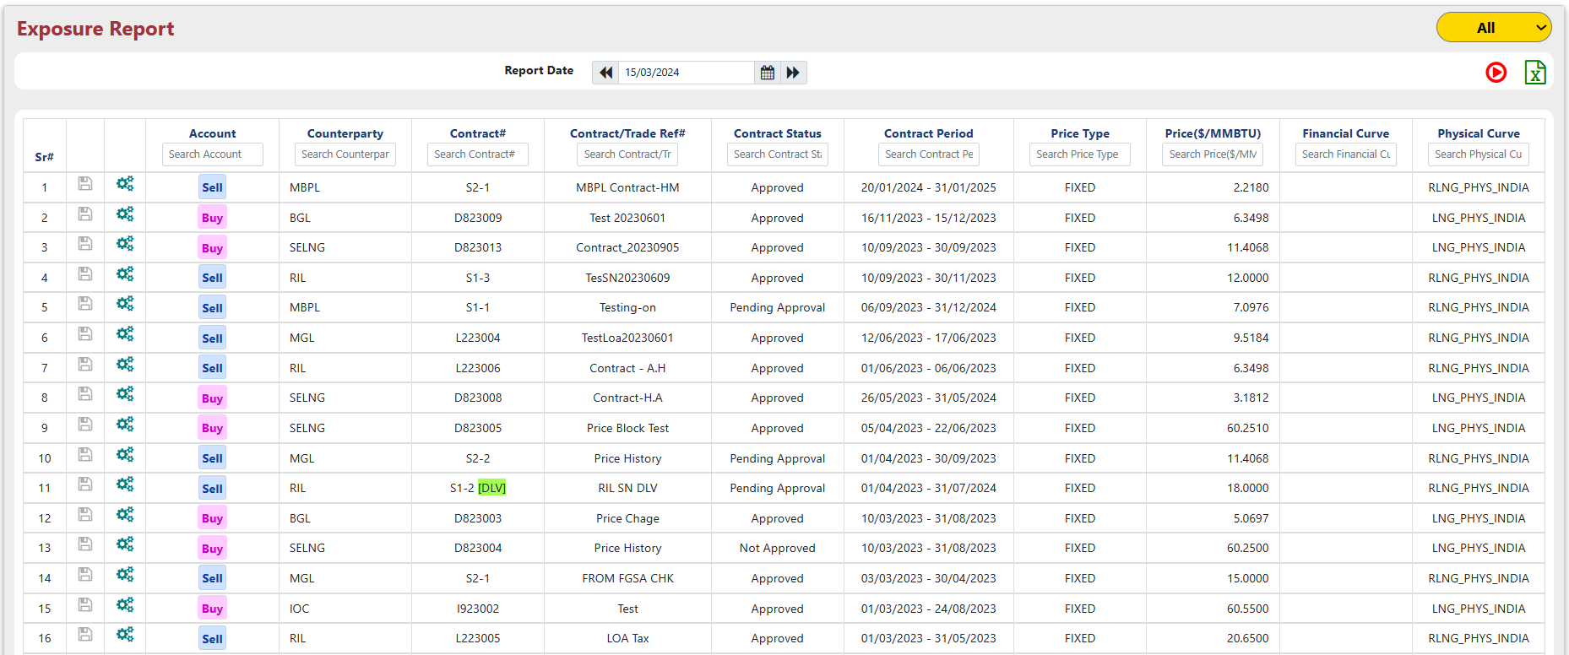

- The "All/Payable/Receivable" dropdown in "Exposure Report" filters your exposure view between all deals, payments (Payable - Buy) or receivables (Receivable - Sell).
- The "Exposure Report" offers "Export to Excel" functionality, allowing you to download a file containing the displayed data by clicking the Excel icon.
- Clicking the "gear" icon on a contract within the "Exposure Report" reveals a detailed breakdown calculated for that specific counterparty-contract combination, with a "Back" button for returning to the previous view.
- Clicking the "Save" icon on a contract in the "Exposure Report" displays a detailed report with frozen data collected by the "EOD Process" for that specific counterparty-contract; use the "Back" button to return.
- In the "Exposure Report," the "Save" icon (turning green when clicked) allows viewing detailed, frozen data collected by the "EOD Process" for a specific counterparty-contract, but only if the data is already frozen within the system (indicating successful completion of the "EOD Process").

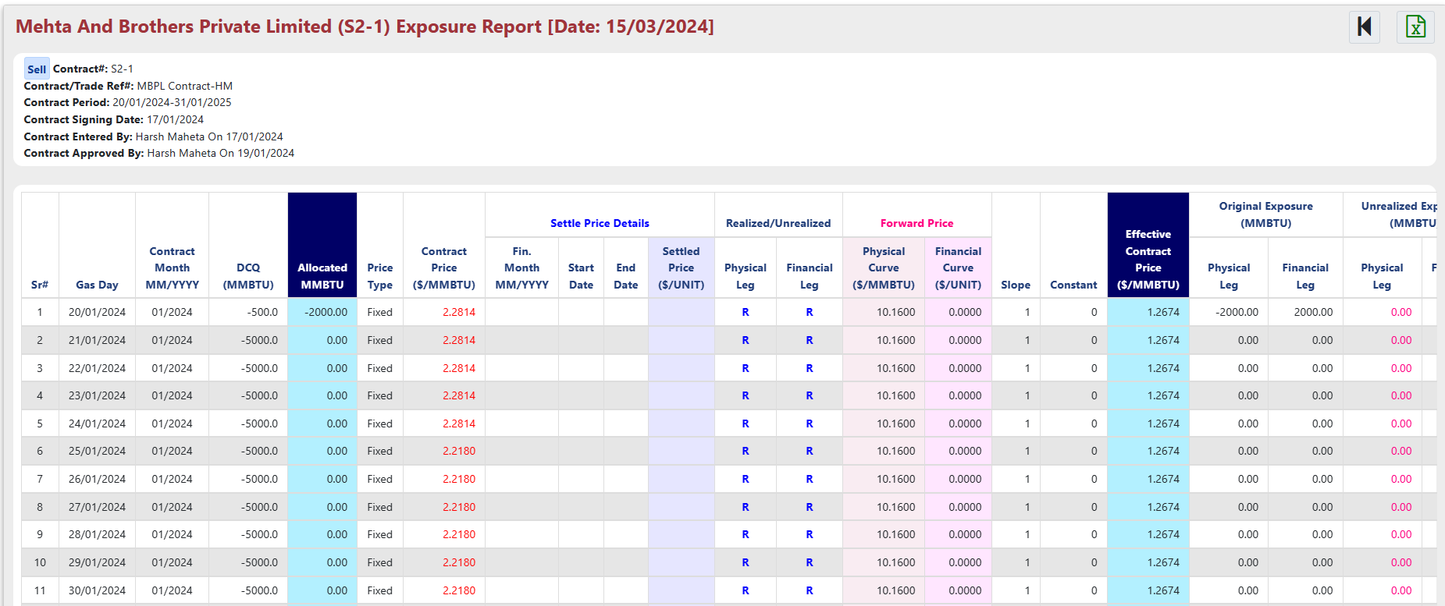


- The "Exposure Report" facilitates manual execution of the EOD process for the previous day's data. Simply click button to initiate this process manually.

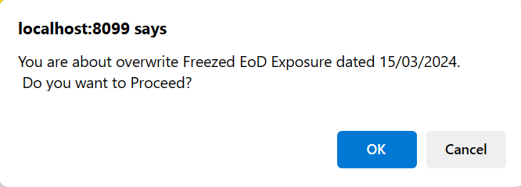

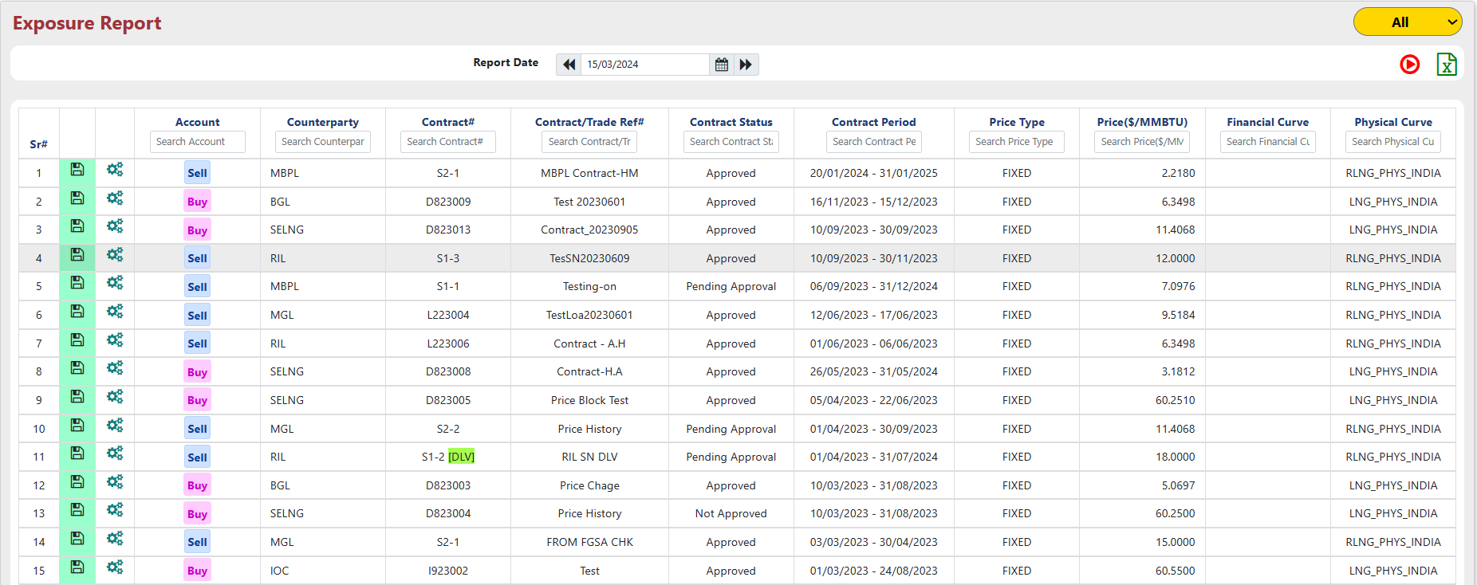

Market Risk QP Exposure Report

In the "QP Exposure" report, analyze a specific deal's exposure, forward price, and linked curve (financial/physical) by its deal number.

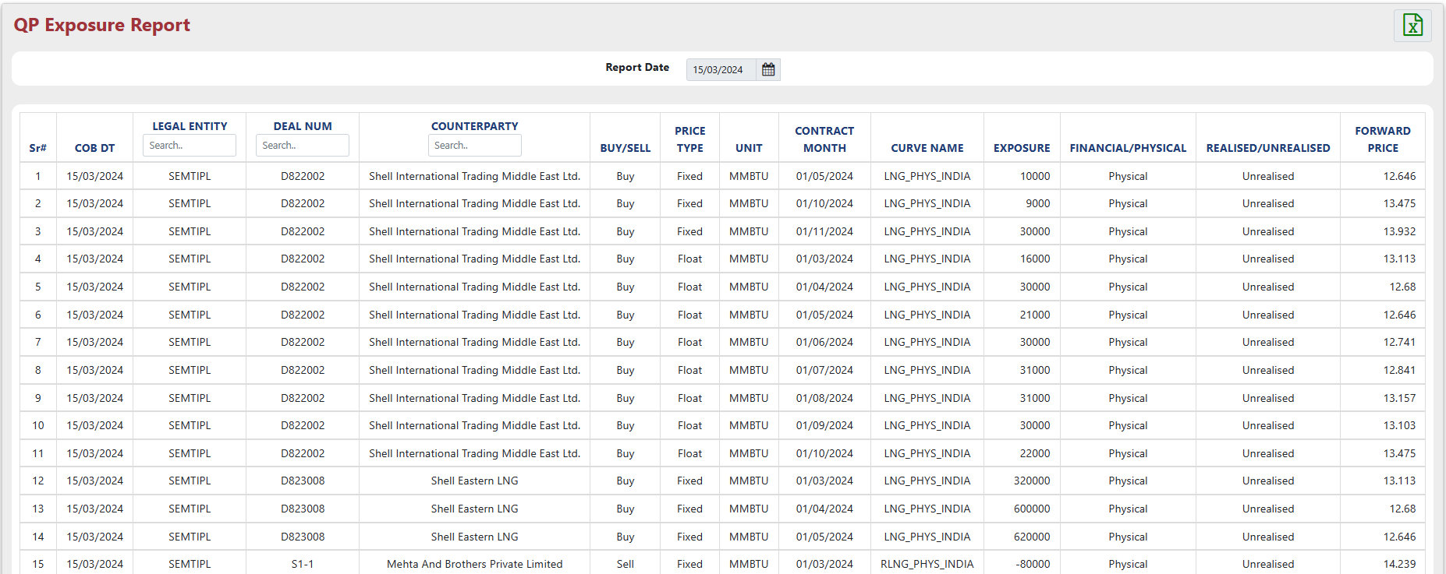

- The QP Exposure report displays yesterday's data with "Export to Excel" functionality for downloading the details.

Market Risk Late Deal Report

The "Late Deal Report" flags overdue deals using pre-set criteria within the system.
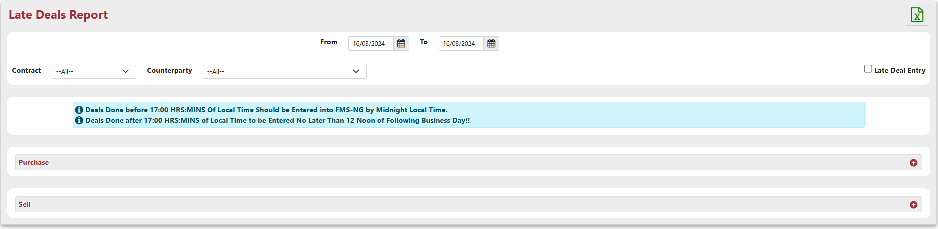

- The "QP Exposure" report lets you drill down for specific deals by selecting contract type, counterparty, and a date range.
- In the "Late Deal Report," a "Late Deal Entry" checkbox filters the view to show only overdue deals identified by the system's criteria.
  - Deals Done before Declared time Of Local Time Should be entered into FMS-NG by Midnight Local Time.
  - Deals Done after Declared time of Local Time to be Entered No Later than 12 Noon of Following Business Day!!
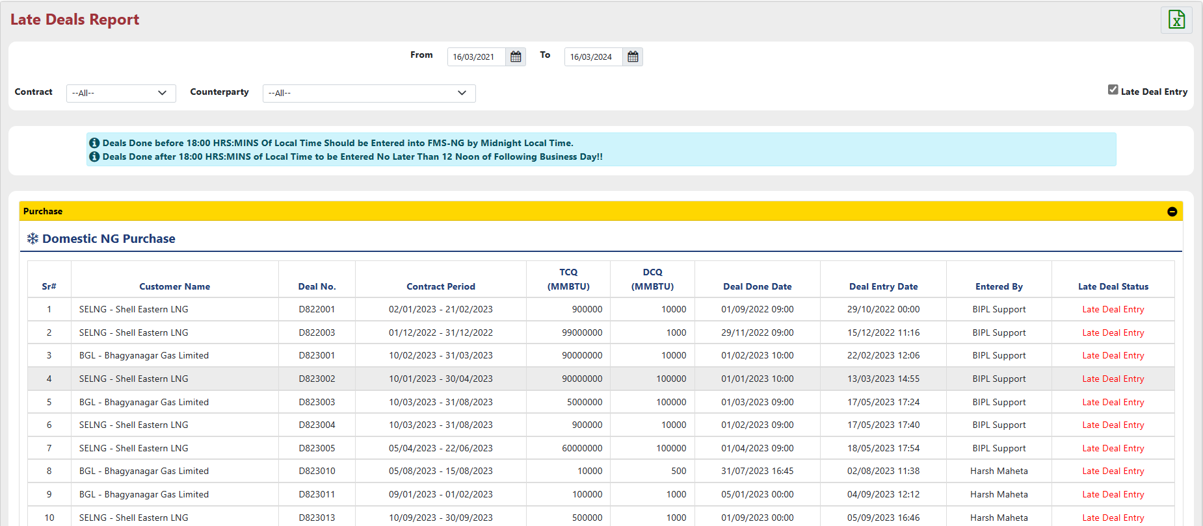

Market Risk Deal Audit History

The "Deal Audit History" report serves as a chronological log, tracking all edits made to buy and sell deals within the system for audit trails

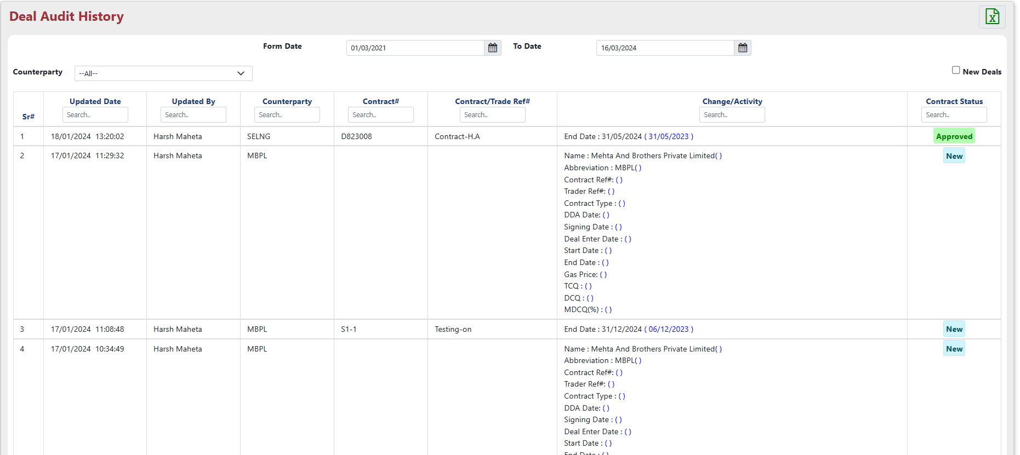

- This report offers a search function with "date range" and "counterparty" filters to refine results, along with "Export to Excel" for downloading the data.
- The report provides a "New Deal" checkbox to filter and display only deals recently created in the system.

Sub Module – Credit Risk

"Credit Risk" sub module used to handle diverse system configurations through the following menus:
- Credit Limit Mgmt/Credit Rating: The "Credit Limit Mgmt/Credit Rating" form acts as a central hub for managing credit limits and ratings assigned to counterparties and banks across the entire system.
- Credit Exceed Days: The "Credit Exceed Days" functionality lets you define or modify the grace period for counterparties exceeding their credit limits.
- Limit Summary Report: The "Limit Summary Report" consolidates all credit limit data for counterparties and banks into a single, comprehensive report.
- Collateral Mgmt: The "Collateral Mgmt" form provides a central location for managing and assigning collateral (securities) to counterparties within the system.
- Advance Booking: The "Advance Booking" form facilitates managing and pre-defining collateral (securities) to be used for specific counterparties within the system.
- Exposure Tracking Report: The Exposure Tracking Report details exposure across all receivable contracts associated with each counterparty.
- Bank Limit and Exposure Report: The "Bank Limit and Exposure Report" provides a comprehensive view of bank limits, exposures, associated customer names, and relevant contracts.
- Walkforward Exposure Report: The "Walkforward Exposure Report" visualizes a counterparty's credit limits and settlement exposure over time using a graphical representation.
- Upcoming Security Report: The "Upcoming Security Report" offers a consolidated view of all forthcoming collateral (security) details within a single report.
- Security Status Report: The "Security Status Report" provides a real-time details of the current status for any security (collateral) held within the system.
- KPI Report: The "KPI Report" offers a comprehensive overview of incoming and outgoing securities, including a summarized view.
- Exceed Credit Report: "Exceed Credit Report" details credit limit breaches for specific customers and contracts, including explanations for the exceedances.
- Receivable Report: The "Receivable Report" details outstanding balances (due amount), remaining days until due, and associated contract numbers for a specific counterparty.
- Audit Report: The "Audit Report" tracks all modifications made to security details, credit limits, and security ratings within the system.
- IGX Margining Report: The IGX Margining Report visualizes collateral value (BG value), available and used margins, along with contract-level details for each counterparty.
- Payment Status Report: The "Payment Status Report" lets you track the payment status for any collateral linked to a specific invoice.
- GEM Report: The "Global Exposure Management Report" offers a consolidated view of unbilled receivables, unbilled payables, gross exposure, cash collateral, and other relevant metrics.
- Pre-Deal Credit Check: "Pre Deal Credit Check" facilitates initiating, modifying, and viewing credit check requests for deals.
- All Security Report: The "All Security Report" consolidates details for all collateral (securities) within the system into a comprehensive report.

Credit Risk Credit Limit Mgmt/Credit Rating

The "Credit Limit Mgmt/Credit Rating" form centralizes management of credit limits and ratings for all counterparties and banks in the system.

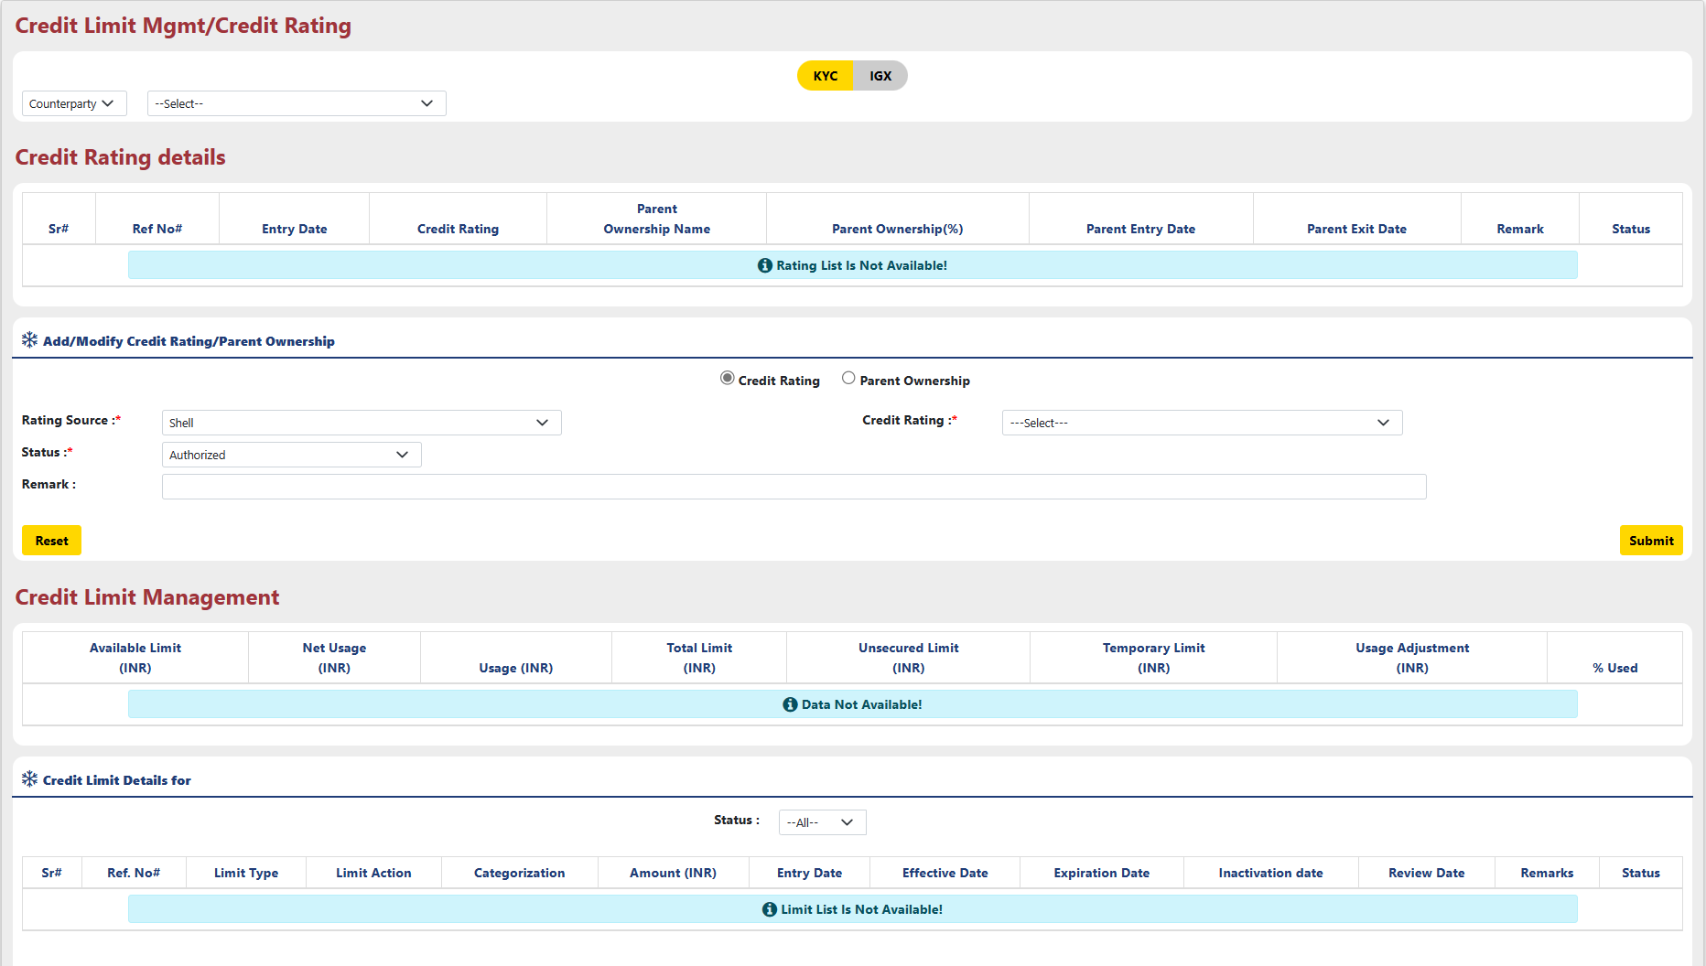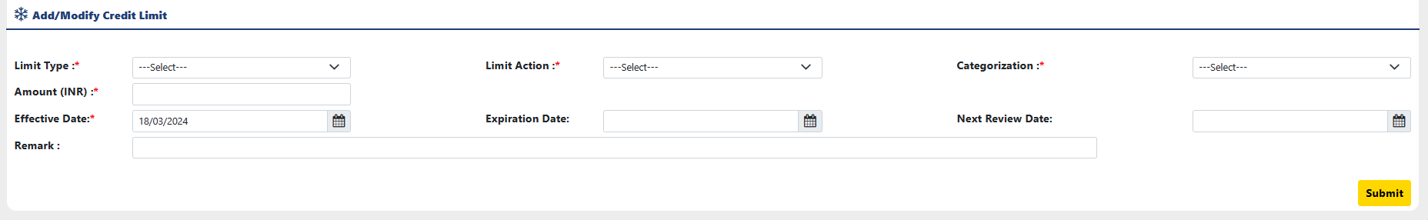

- The dropdown menu lets you select a counterparty or bank for further actions.
- Credit Rating Details:
  - The 'Credit Rating Details' table shows credit ratings and parent company information for banks and counterparties.
- Add/Modify Credit Rating/Parent Ownership: Update counterparty/bank credit ratings and parent ownership details through the 'Add/Modify Credit Rating/Parent Ownership' function
  - Choose a radio button to indicate whether you want to add a new credit rating or modify the parent ownership.
  - For Credit rating :
    - Rating Source: Rating Source defaults to "Shell" within this menu.
    - Choose a credit rating from the dropdown (A=best, E=worst).
    - Select the rating status (e.g., authorized, unauthorized) from the dropdown menu.
    - Explain the credit rating in the remarks field.
  - For Parent Ownership:
    - Choose the parent legal entity from the dropdown menu.
    - Enter the parent company's ownership percentage.
    - Specify the parent company's entry and exit dates.
    - Select the rating status (e.g., authorized, unauthorized) from the dropdown menu.
    - Fill up the remarks section (if needed).
  - Clicking "Submit" prompts a confirmation window; click "Ok" to proceed.
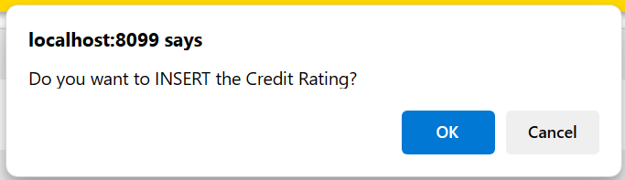
- A success message will be displayed upon successful completion.
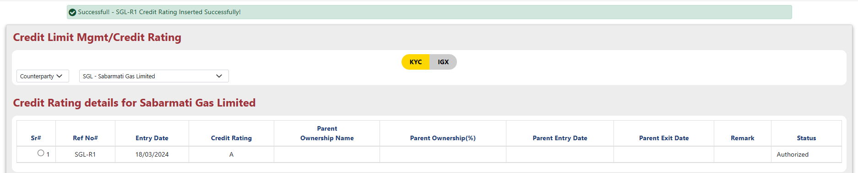
- Select a counterparty/bank using the radio button next to their "ref#" to manage either credit rating/ownership or credit limits.
  - Provide Limit Type from the dropdown: This step involves choosing the type of credit limit you're setting.
  - Select Limit Action from the dropdown: This allows you to specify “Adjust Limit” or “Adjust Usage”.
  - Select Categorization from the dropdown: Choose how the limit is categorized
  - Amount: Enter the actual credit limit value, typically a numerical amount representing the maximum exposure allowed.
  - Select Effective Date: Specify the date from which the credit limit becomes active.
  - Provide Expiration Date: If the credit limit has a defined expiration date, enter it here.
  - Next Review Date: This could be used to set a reminder for reviewing and potentially adjusting the credit limit in the future.
  - Give Remarks: You can provide any additional comments or justifications for the chosen credit limit and its configuration.
- Clicking "Submit" prompts a confirmation window; click "Ok" to proceed.

- Note:
- If Limit type is not “Unsecured” and Action type is “Adjust Usage” then entered amount will be consider as usage adjustment.
- if Limit Type is “Unsecured” and Action type is “Adjust Limit” then entered amount will consider be as Unsecured Limit.
- If Limit Type is “Temporary” and Action Type is “Adjust Limit” then entered amount will consider as Temporary Limit.
- All the Active entries with Action type “Adjust Limit” will consider as a Total Limit.

Credit Risk Credit Exceed Days

The "Credit Exceed Days" functionality lets you define or modify the grace period for counterparties exceeding their credit limits.
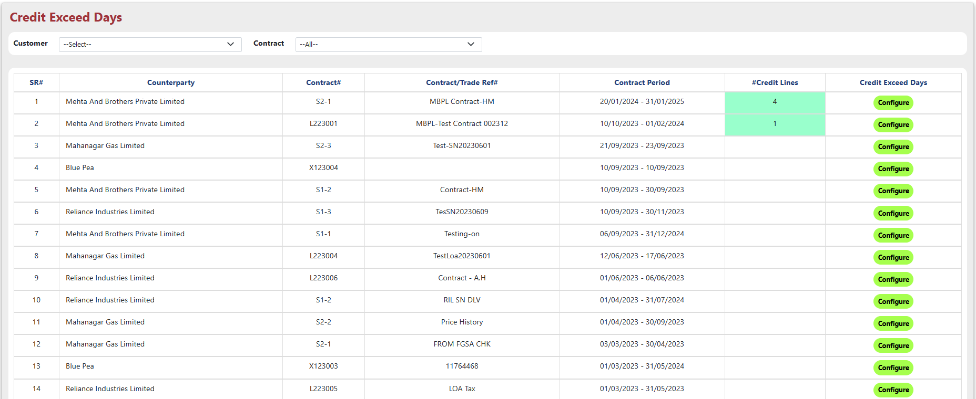
- Specify customer and contract for customized view.
- The 'Configure' button allows you to set grace period for counterparties exceeding credit limits (Credit Exceed Days).
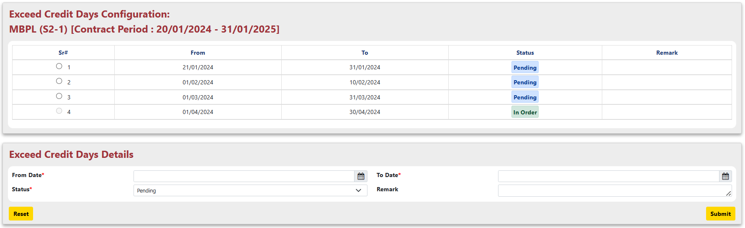
- Select the radio button next to the detail you want to edit.

- From Date: Specify the "From Date" for identifying counterparties exceeding credit limits.
- To Date: Specify the "To Date" for identifying counterparties exceeding credit limits.
- Status: Choose the status for Exceed Credit Days details.

- Clicking "Submit" prompts a confirmation window; click "Ok" to proceed.

Credit Risk Limit Summary Report

The "Limit Summary Report" consolidates all credit limit data for counterparties and banks into a single, comprehensive report.
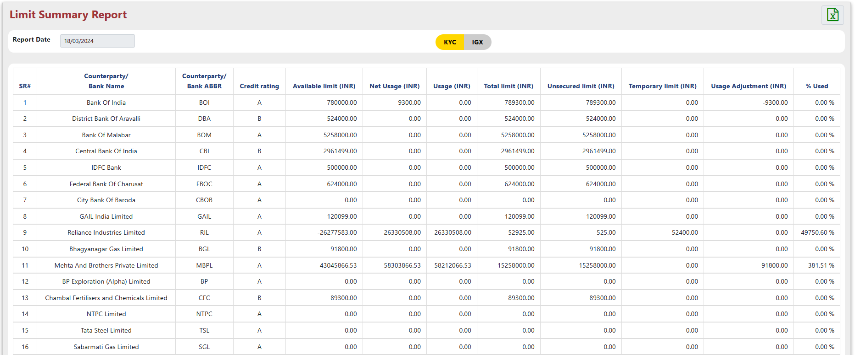
- Choose "KYC" or "IGX" using the buttons to filter the displayed data.
- The "Limit Summary Report" offers "Export to Excel" functionality for downloading a detailed excel file.

Credit Risk Collateral Mgmt

The "Collateral Mgmt" form provides a central location for managing and assigning collateral (securities) to counterparties within the system.
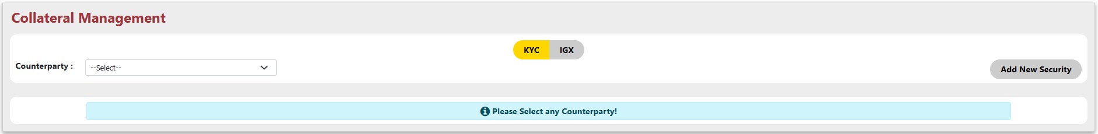
- Choose a counterparty from the dropdown and select 'KYC' or 'IGX' using the buttons to filter specific data.
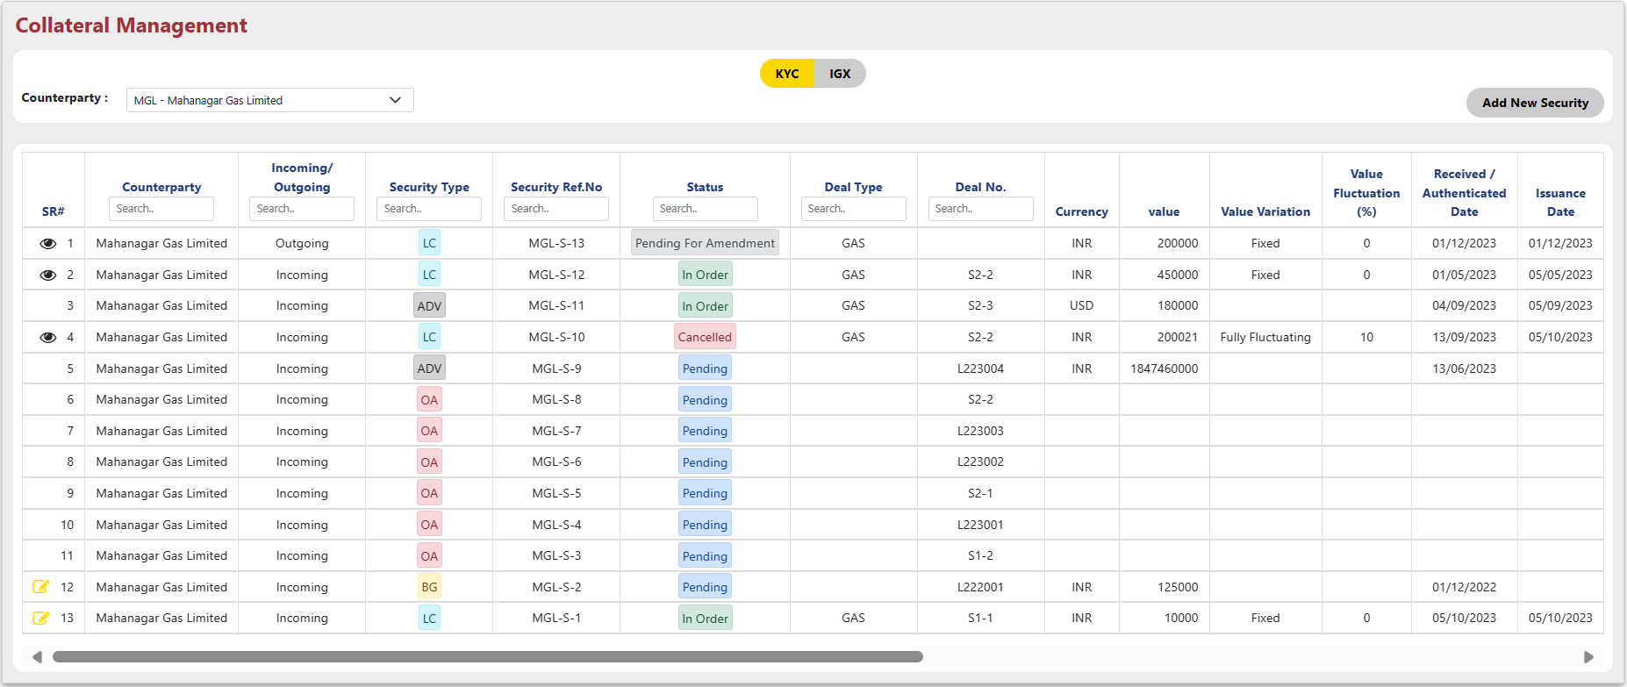
- Clicking 'Add New Security' lets you assign new collateral to the selected counterparty.
- Use the 'Pen Icon' next to a counterparty to modify their assigned collateral details.
- Fill required fields and click 'Submit' to add or edit collateral for the selected counterparty.
  - Counterparty: Select the Counterparty from the dropdown.
  - Category: Select Category from the dropdown.
  - Deal Type: Deal Type will be default on ‘Gas’.
  - Attach Contract#: This button allows you to attach contract to the collateral.
  - Security value: Provide security value and select the currency from the dropdown.
  - Value Fluctuation %: Enter the Value Fluctuation is percentage and positive or negative (+/-).
  - Issuing Bank: Select the issuing bank from the dropdown.
  - Issuing Bank Ref#: Provide the bank reference or detail for the issuing bank.
  - Advising Bank: Select the advising bank from the dropdown.
  - Advising Bank Ref#: Provide the bank reference or detail for the advising bank.
  - Confirming Bank: Select the confirming bank from the dropdown.
  - Confirming Bank Ref#: Provide the reference or detail for the confirming bank.
  - Recv./Auth. Date: Provide authenticated or received date.
  - Review Date: Select the review date for the security.
  - Issuance Date: Provide the Issuance Date for the collateral date.
  - Expire Date: Select the Expire Date for the collateral.
  - Status: Select the status for the security.
  - Remark: Provide the additional details for the security.
  - Tenor: Will be calculated automatically.

- Clicking "Submit" confirms either adding or modifying security.

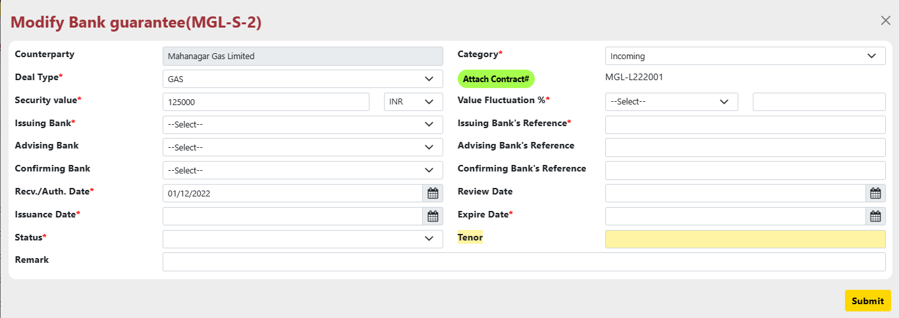

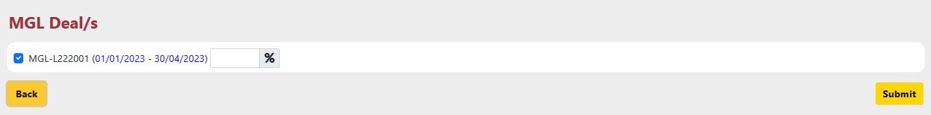

Credit Risk Advance Booking

The "Advance Booking" form facilitates managing and pre-defining collateral (securities) to be used for specific counterparties within the system.
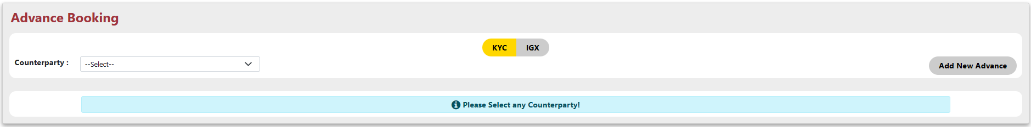
- Choose a counterparty from the dropdown and select 'KYC' or 'IGX' using the buttons to filter specific data.
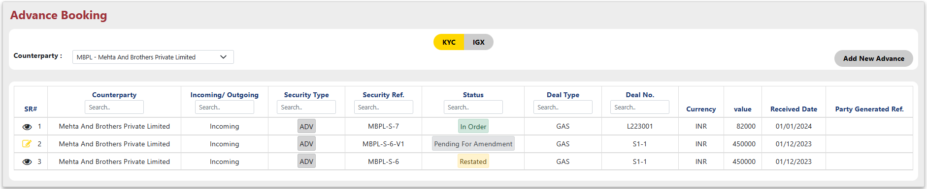
- Use the 'Pen Icon' next to a counterparty to modify their assigned collateral details.
- Fill required fields and click 'Submit' to add or edit collateral for the selected.
  - Counterparty: Select the Counterparty from the dropdown.
  - Category: Select Category from the dropdown.
  - Security Type: Security Type will be default on ‘ADV Advance Payment’.
  - Attach Contract#: This button allows you to attach contract to the collateral.
  - Expected Receipt (Due) Date: Select the Expected Receipt (Due) Date for the collateral.
  - Amount: Provide the amount for the security and select the amount currancy.
  - Remark: Provide the additional details for the security.
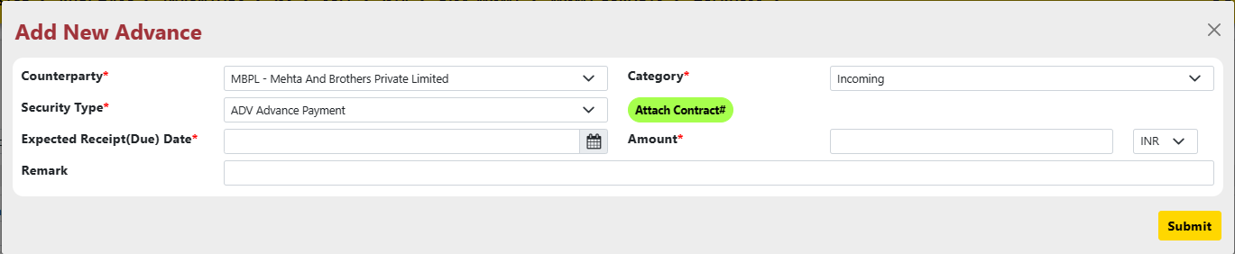

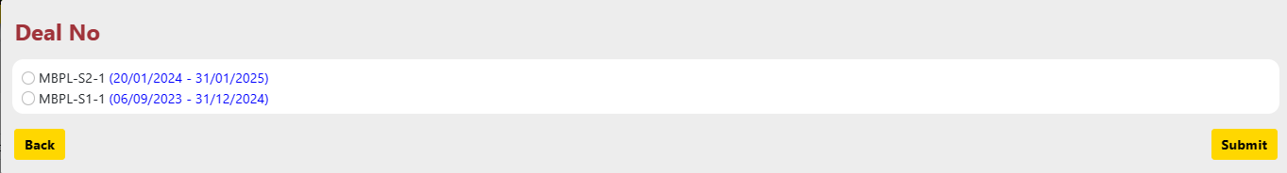
- Note: Securities with "Restated" or "In Ordered" status are read-only (Eye symbol).

Credit Risk Exposure Tracking Report

User can Track counterparty exposure across all their associated receivable contracts with the Exposure Tracking Report.
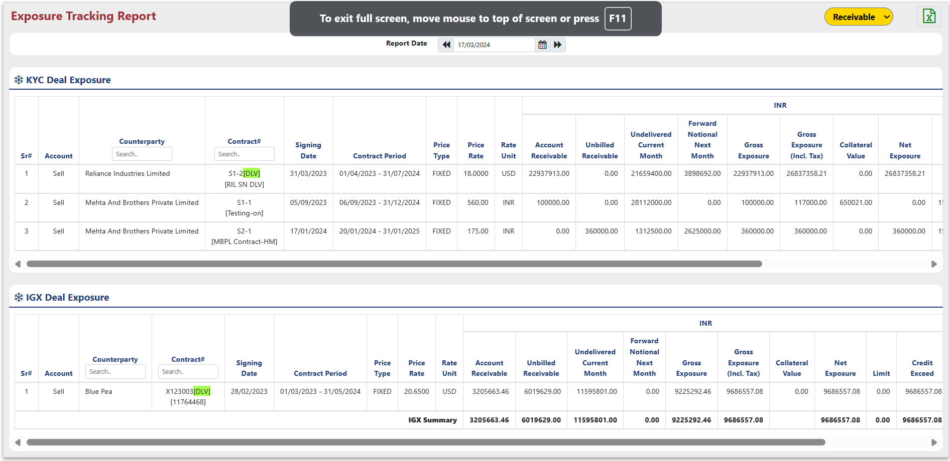
- Exposure Tracking Report offers "Export to Excel" functionality for downloading a detailed excel file.

Credit Risk Bank Limit and Exposure Report

The "Bank Limit and Exposure Report" provides a comprehensive view of bank limits, exposures, associated customer names, and relevant contracts.
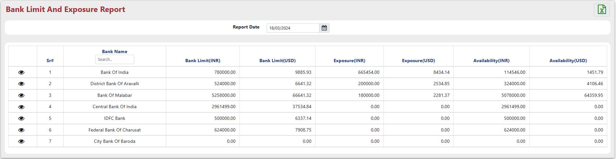
- Clicking the eye icon reveals detailed counterparty and contract-level exposure for any bank within the Exposure Report.
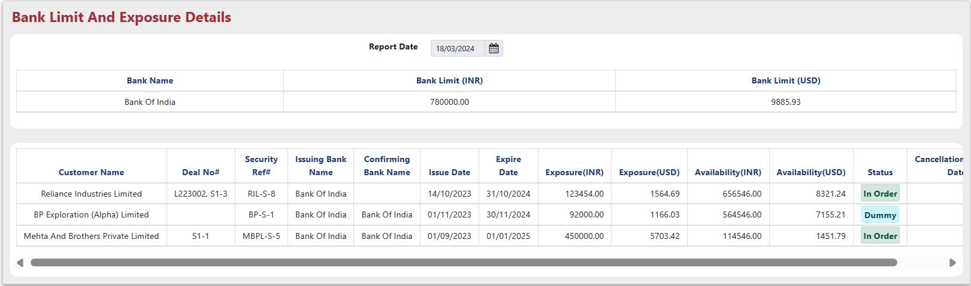
- Note:
- Bank limit will come only if Limit Status is active. and for Security details, Security Must be “LC or BG” with status “IN ORDER, CALNCELLED, RESTATED or DUMMY” and bank attached as a Issuing Bank or Confirming Bank.

Credit Risk Walkforward Exposure Report

The "Walkforward Exposure Report" visualizes a counterparty's credit limits and settlement exposure over time using a graphical representation.
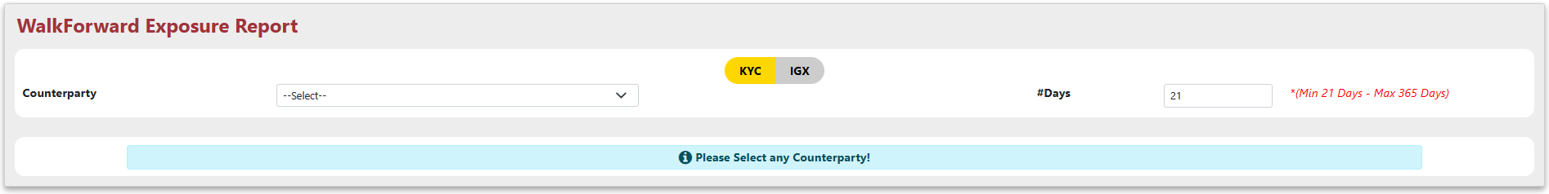
- Selecting a counterparty and entering days lets you visualize their credit limit and settlement exposure over time.
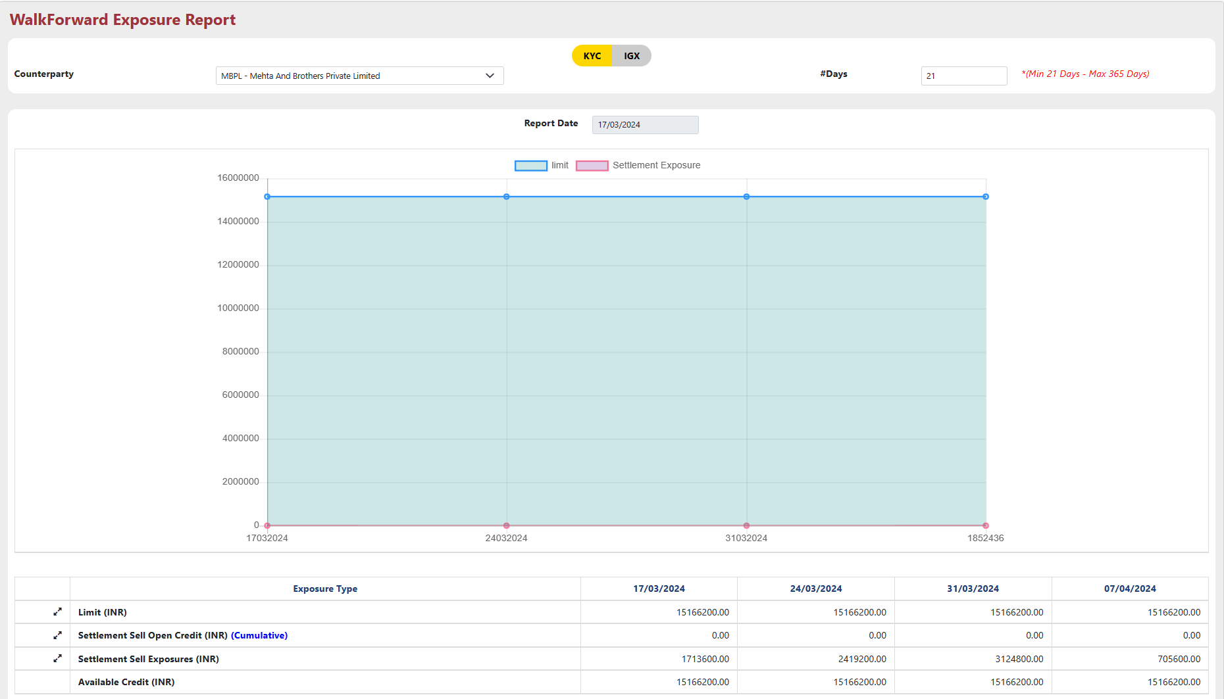
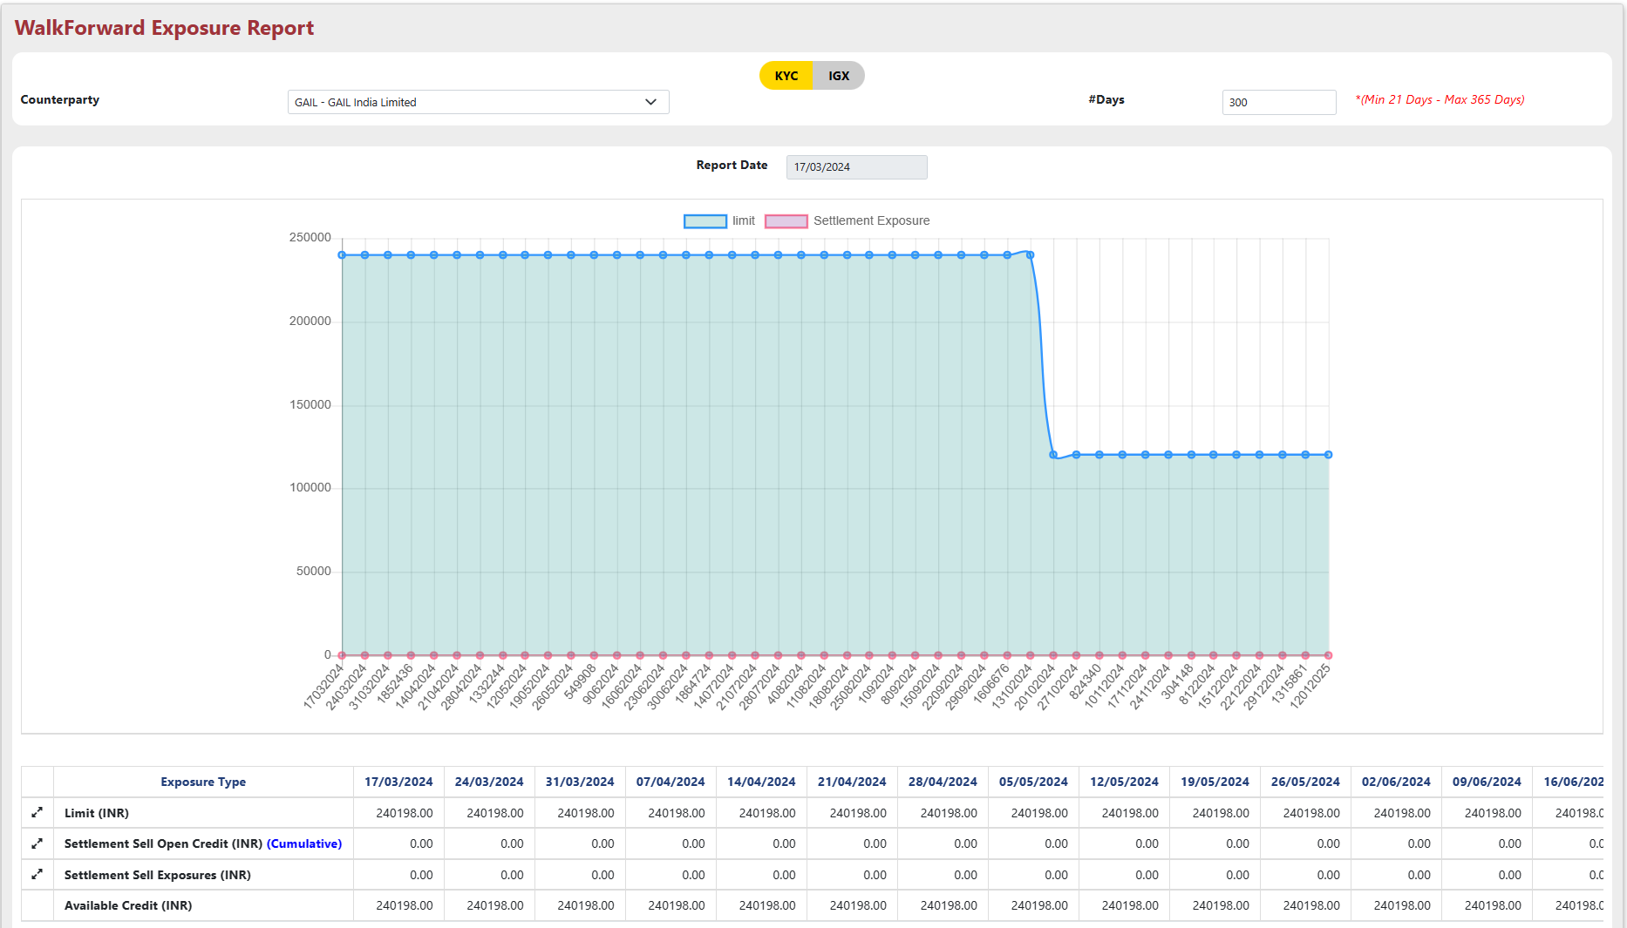
- By clicking the expansion icon will show the detailed data for limit, credit and exposure.

- Note:
  - Total of Active Limit for the counterparty and Parents Limit with attached active PCG Security with “IN ORDER” status will be shown in Limit Section.
  - When expand Limit, Active Limit of Parent attached as a PCG Security with “IN ORDER” status will be shown.
  - In Settlement Sell Open Credit, Incoming PCG or OPEN ACCOUNT Security with “Pending or Pending for Amendment” status with attached Deal, and security must not have issuance date.
  - In Settlement Sell Exposure, Incoming LC or BG Security with “Pending or Pending for Amendment” status with attached Deal, and security must not have issuance date.

Credit Risk Upcoming Security Report

The "Upcoming Security Report" offers a consolidated view of all forthcoming collateral (security) details within a single report.
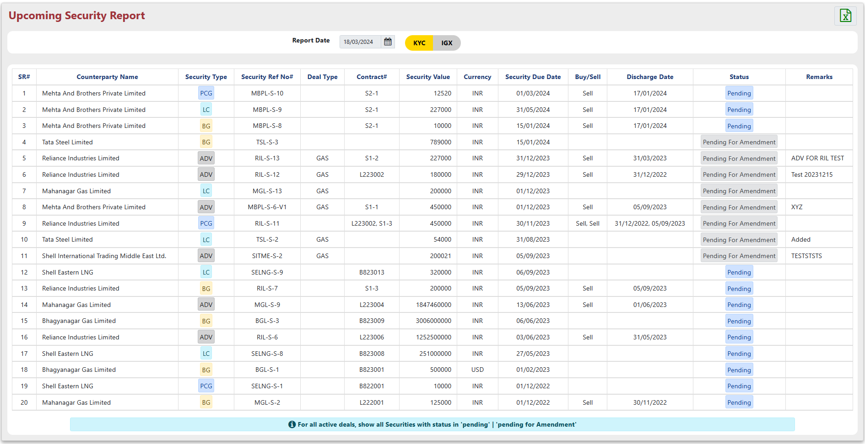
- Note:
  - “For all active deals, show all Securities with status in 'pending' | 'pending for Amendment'” means Show active deals that contain Securities with a status of "pending" or "pending for Amendment".

Credit Risk Security Status Report

The "Security Status Report" provides a real-time details of the current status for any security (collateral) held within the system.
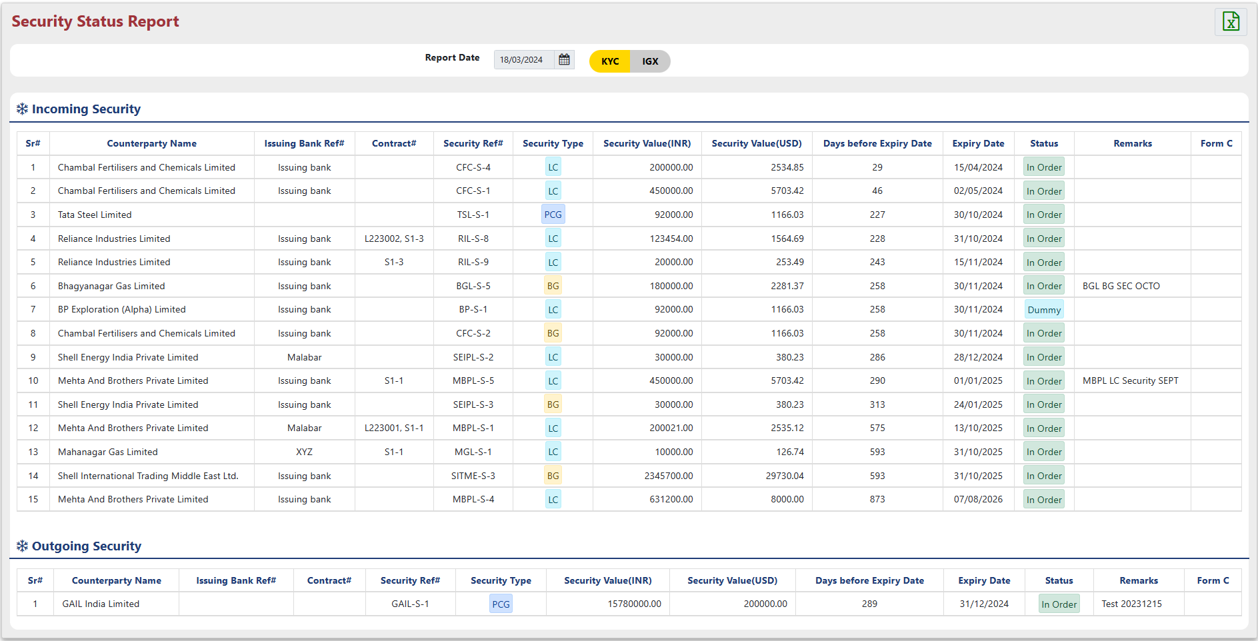
- The report should further categorize the data into incoming and outgoing categories.
- Security Status Report offers "Export to Excel" functionality for downloading a detailed excel file.

Credit Risk KPI Report

The KPI Report offers a clear picture of security movement (incoming and outgoing) with both a comprehensive view and a helpful summary.
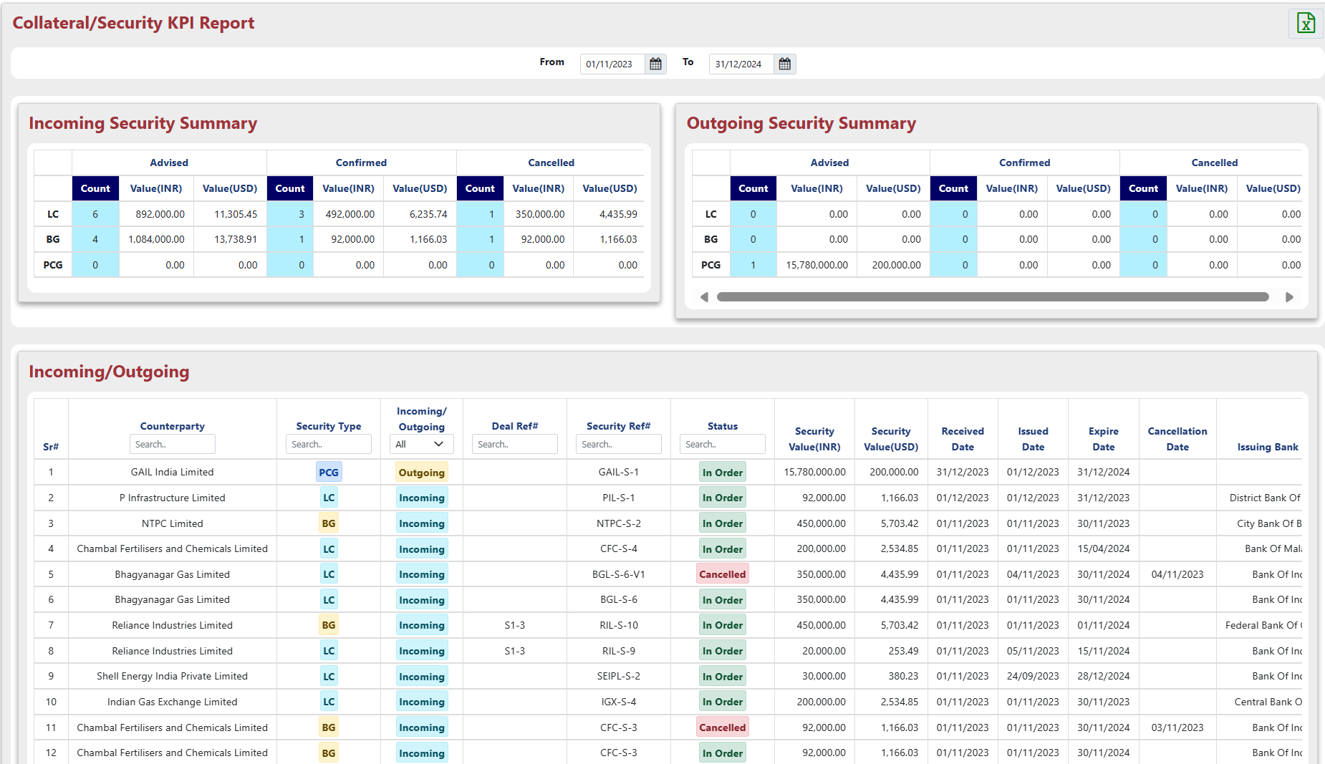

- KPI Report offers "Export to Excel" functionality for downloading a displayed data excel file.

- Note:
- LC, BG and PCG security will be shown in this report with the status “IN ORDER and CANCELLED”. And Received Date must be between selected date range.
- If security have “IN ORDER” status and Confirming Bank is attached with security than it will come under “Confirmed” part.
- If security have “IN ORDER” status and Confirming Bank is not attached with security than it will come under “Advised” part.
- If security have “CANCELLED” status it will come under “Cancelled” part.

Credit Risk Exceed Credit Report

"Exceed Credit Report" details credit limit breaches for specific customers and contracts, including explanations for the exceedances.
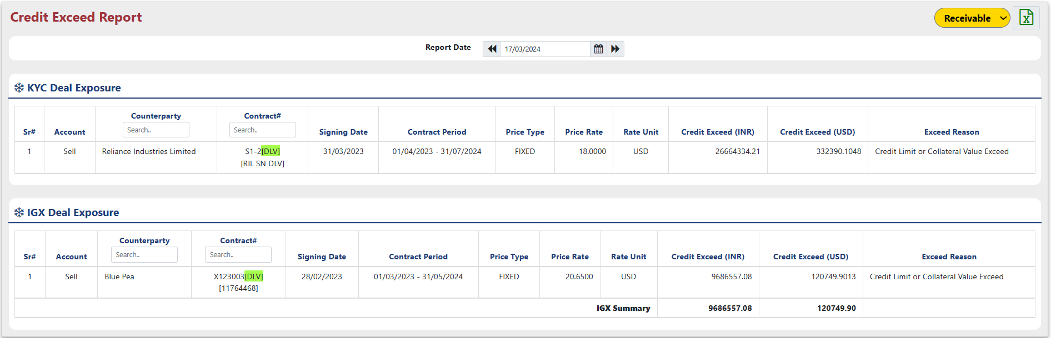
- The "Credit Limit Report" shows customers and contracts that went over their credit limits, and why it happened.
- Credit Exceed Days report offers "Export to Excel" functionality for downloading a displayed data excel file.

Credit Risk Receivable Report

For a specific counterparty, the "Receivable Report" provides a snapshot of outstanding invoice balances (amount due), remaining days until payment is due, and linked contract numbers, all as of the previous day.
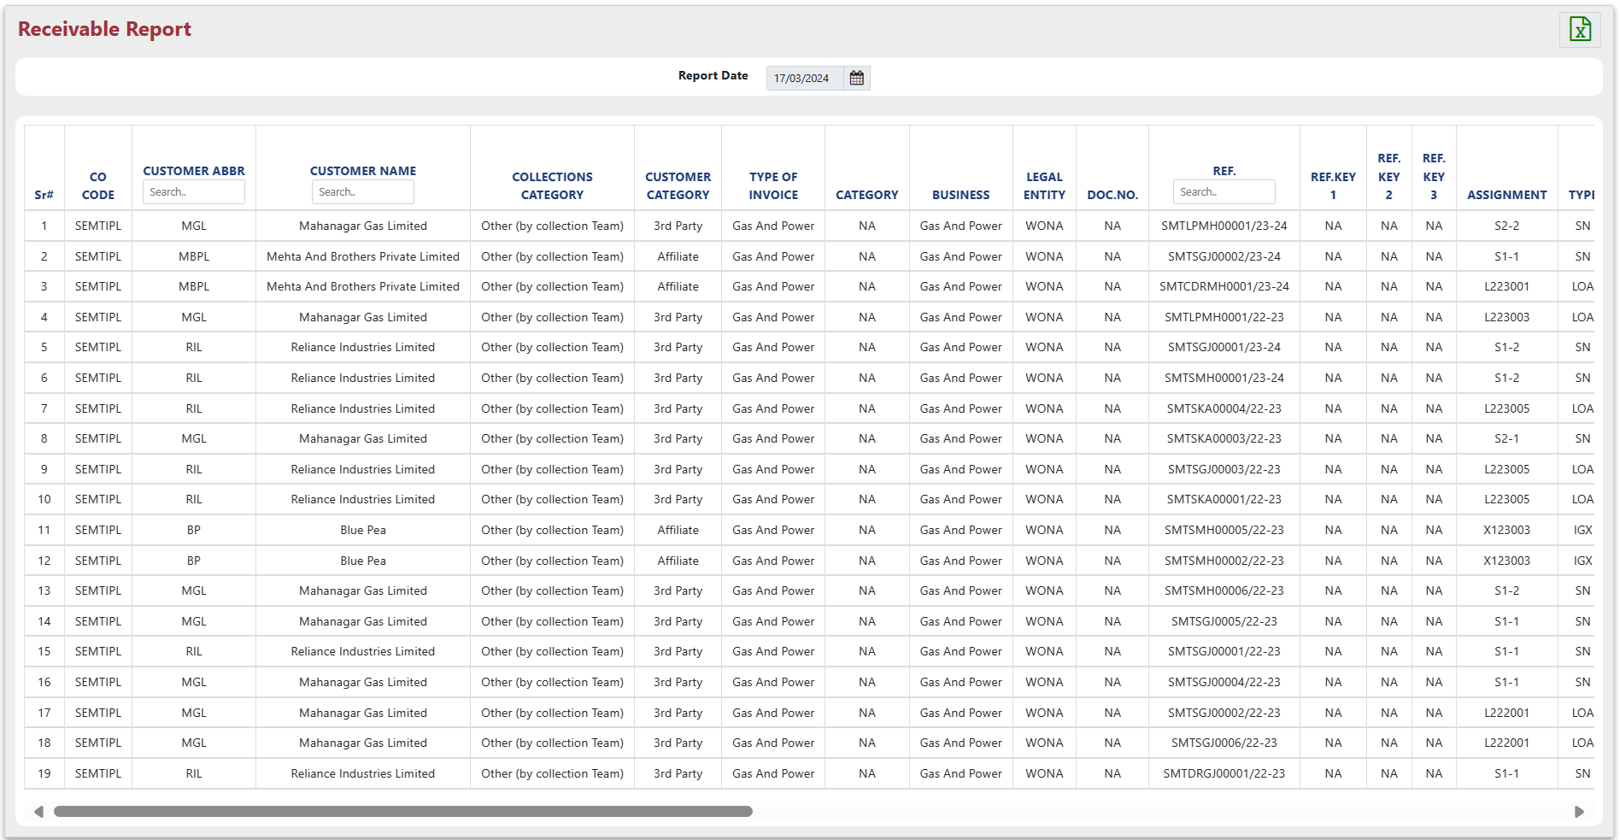
- Receivable Report offers "Export to Excel" functionality for downloading a displayed data excel file.

Credit Risk Audit Report

The "Audit Report" tracks all modifications made to security details, credit limits, and security ratings within the system.
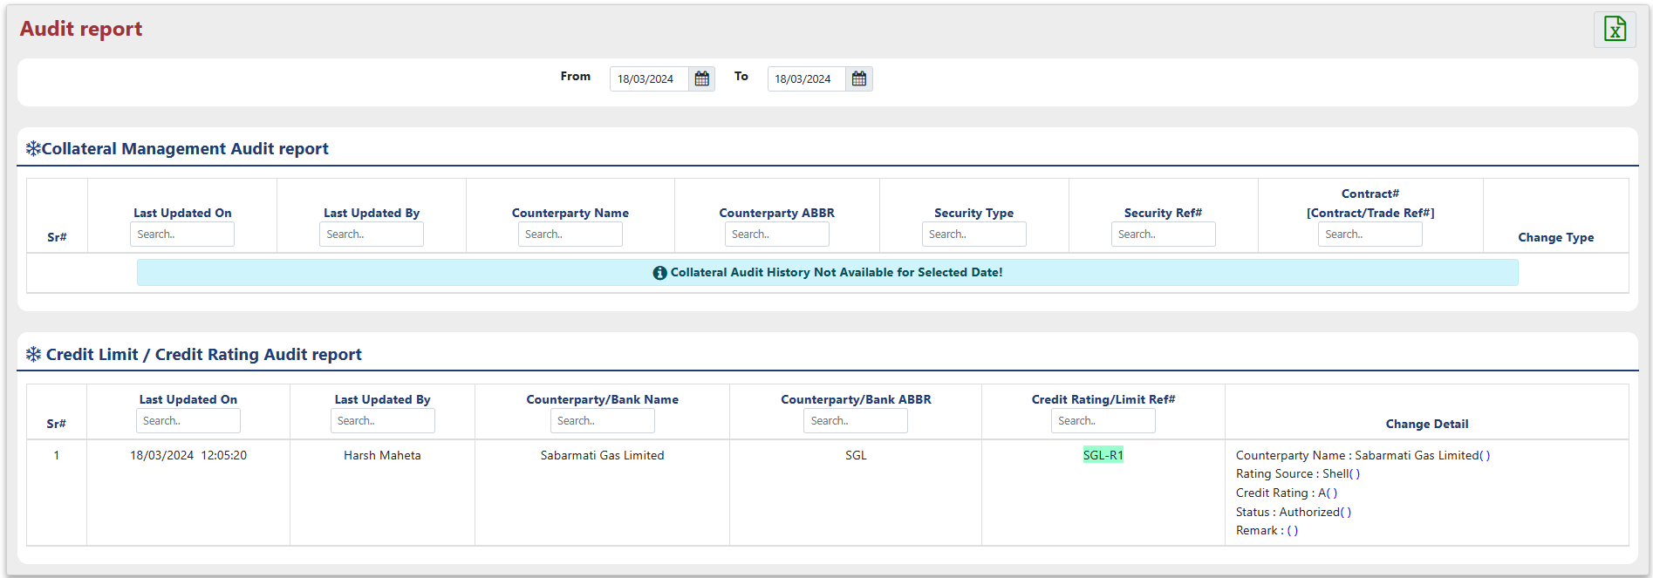
- Apply a new date filter to the results, specifying a new starting and ending date.
- Audit Report offers "Export to Excel" functionality for downloading a displayed data excel file.

Credit Risk IGX Margining Report

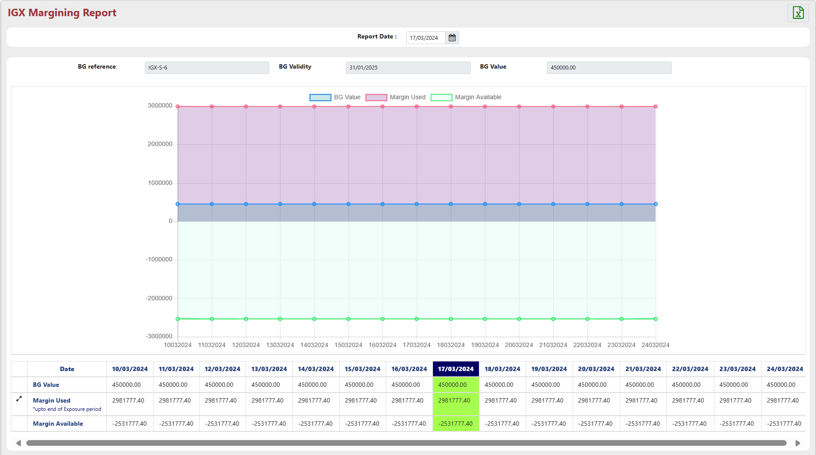
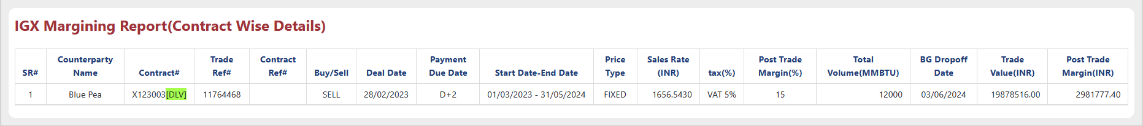
- The IGX Margining Report offers a visual representation of collateral value (bank guarantee value), available and used margins, along with contract details, for each counterparty.
- Adjust the date range for the data.
- IGX Margining Report offers "Export to Excel" functionality for downloading a displayed data excel file.

Credit Risk Payment Status Report

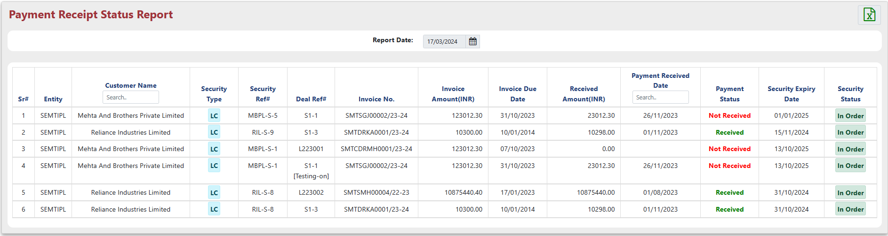
- The "Payment Status Report" lets you track the payment status for any collateral linked to a specific invoice.

Credit Risk GEM Report

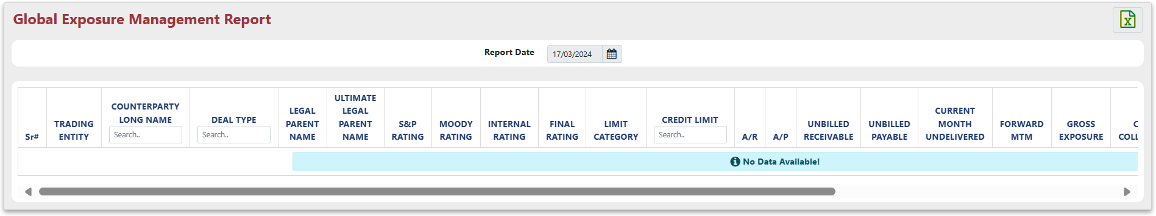
- The "Global Exposure Management Report" offers a consolidated view of unbilled receivables, unbilled payables, gross exposure, cash collateral, and other relevant metrics for the previous day.
- GEM Report offers "Export to Excel" functionality for downloading a displayed data excel file.

Credit Risk Pre-Deal Credit Check

"Pre Deal Credit Check" allows you to start, change, and track credit check requests for deals.
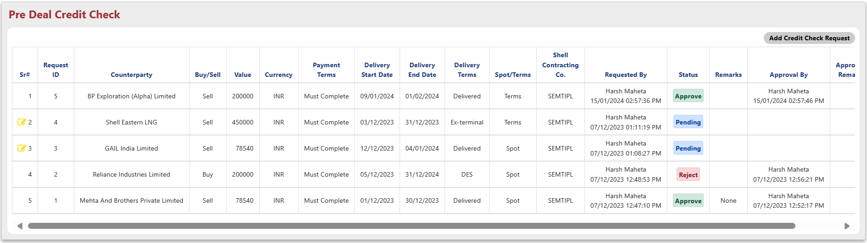
- To add a new credit check request, click "Add Credit Check Request". For existing requests, click the "Pen icon" to make changes.
  - Counterparty: Select the counterparty from the dropdown
  - Sell/Buy: Select that request is for Buy or Sell side.
  - Delivery Start Date: Enter the Delivery Start Date.
  - Delivery End Date: Enter the Delivery End Date.
  - Value: Provide the value of credit check.
  - Currency: Select the currency from the dropdown.
  - Delivery Term: Select the Delivery Term from the dropdown.
  - Spot Term: Select the Spot Term from the dropdown.
  - Shell Contracting Co.: Default as ‘SEMTIPL’.
  - Payment Terms: Provide Payment Terms are if any.
  - Remark: Additional details for request.
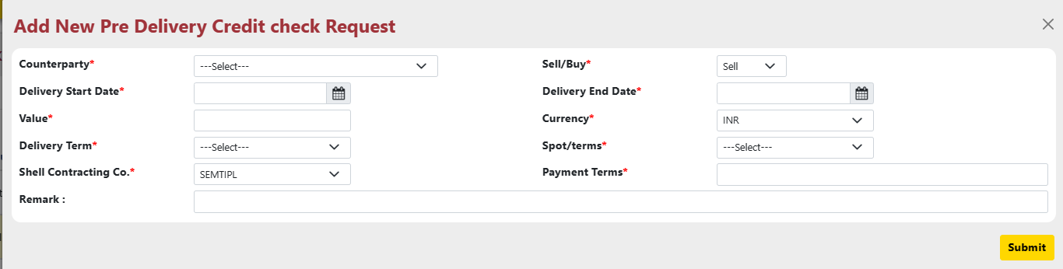
  - Status: Select the status for the request.
  - Approval Message: Describe the action taken by you.
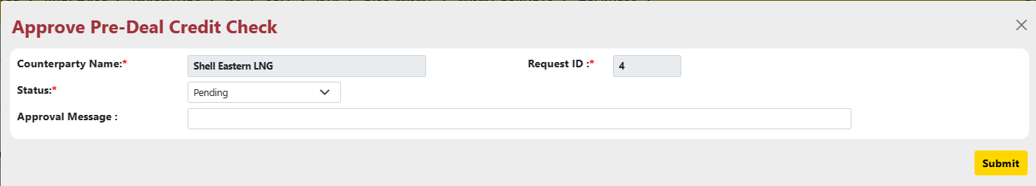
- Click "Submit" and confirm your action in the pop-up window.
- Button will open “WalkForward Exposure Report” as it is sell side request and button will open “Credit Rating Report” as it is buy side request.

Credit Risk All Security Report

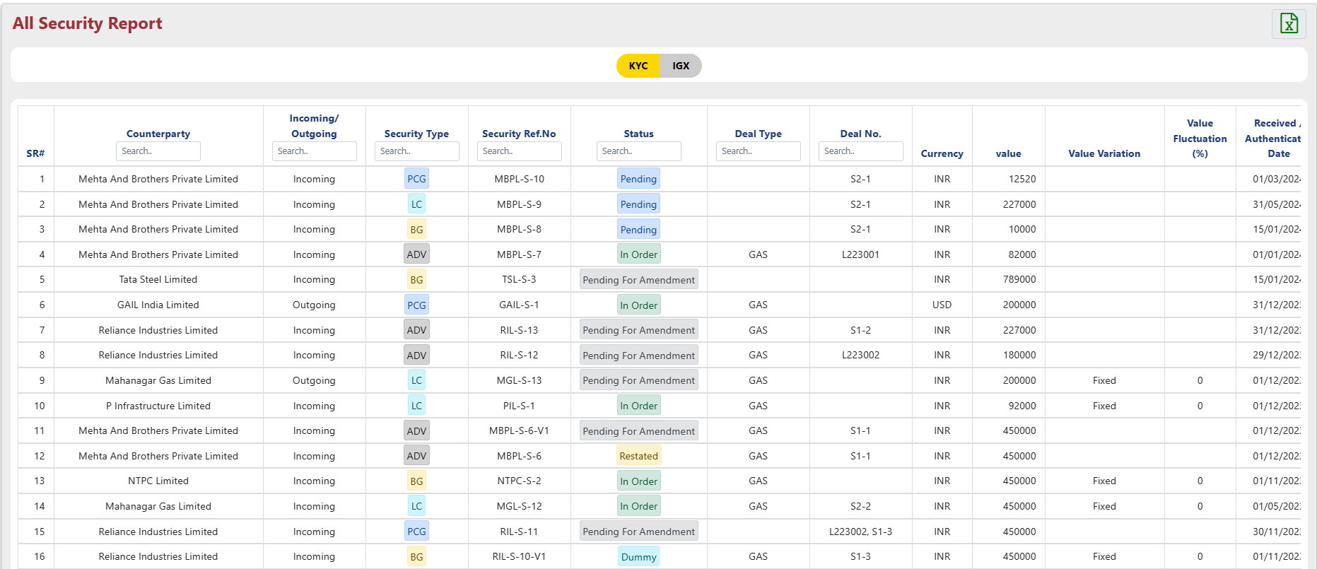

- The "All Security Report" consolidates details for all collateral (securities) within the system into a comprehensive report.
- All Security Report offers "Export to Excel" functionality for downloading a displayed data excel file.

Report Design and Layout

For your reference, detailed information about these reports is provided above:

- Exposure Report
- QP Exposure Report
- Late Deal Report
- Deal Audit History
- Limit Summary Report
- Exposure Tracking Report
- Bank Limit and Exposure Report
- Walkforward Exposure Report
- Upcoming Security Report
- Security Status Report
- KPI Report
- Exceed Credit Report
- Receivable Report
- Audit Report
- IGX Margining Report
- Payment Status Report
- GEM Report
- All Security Report

Auditing
The "Audit Trail" within the "Admin" module comprehensively tracks and stores all user actions performed across the various sub-menus of the "Risk Mgmt" module, providing a detailed record of changes made to the system's master data.

